Chapter 2, Solution 24

- I₀ = 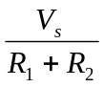

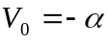I₀ 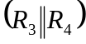 = 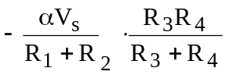

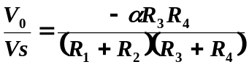

- If R₁ = R₂ = R₃ = R₄ = R,

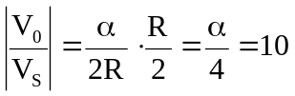 α = 40

